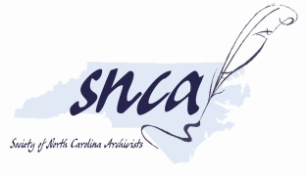

C. David Jackson Memorial Student Scholarship Application
The Society of North Carolina Archivists (SNCA) will offer up to four scholarships of $250 each to support student attendance at the annual meeting, which will be virtual in 2022. A one-year SNCA membership is also included with the scholarship.
Purpose: This scholarship is intended to promote continuing archival education and professional alliances among archivists in North Carolina. In addition to using the scholarship funds to support attendance at the annual meeting, recipients are encouraged to use scholarship funds to register for workshops and other professional development opportunities that would provide supplemental education to existing coursework and work experiences.
Eligibility: Applicants must be students enrolled in an archival studies, public history, or library science program in North Carolina. Previous SNCA scholarship recipients may not make further applications.
Application: Submit this form and a current resume/CV to the Education Committee Chair at joshua.hager@ncdcr.gov. Due date is February 14, 2022.
Disbursement of Funds: Scholarship funds will be provided to the recipients prior to the conference as a one-time payment.

Contact Information:
Name:
Mailing address:
Telephone: Email address:
School attending: Level of education completed:

Interest in Archives
Tell us about your interest in archives. What prompted you to pursue a career in the field? (300 word limit)
Discuss your interest in SNCA and in attending our annual meeting in 2022. (300 word limit)

Archival Training
Check all that apply (left click box to select, then right click to select checkmark):
- No Training
- Volunteer Work
- Undergraduate: Internship, short-term work
- Undergraduate: On-the-job training
- Graduate: Internship, short-term work
- Graduate: On-the-job training
- Workshops
- Other (please explain)
Discuss the ways in which you have pursued archival learning opportunities where you live and/or attend school. You may also choose to address any difficulties or limited opportunities here. (150 word limit)

Professional Development Plans

Let us know more about how you plan to use the scholarship funds to support your professional development. Be sure to include relevant costs. (300 word limit)

